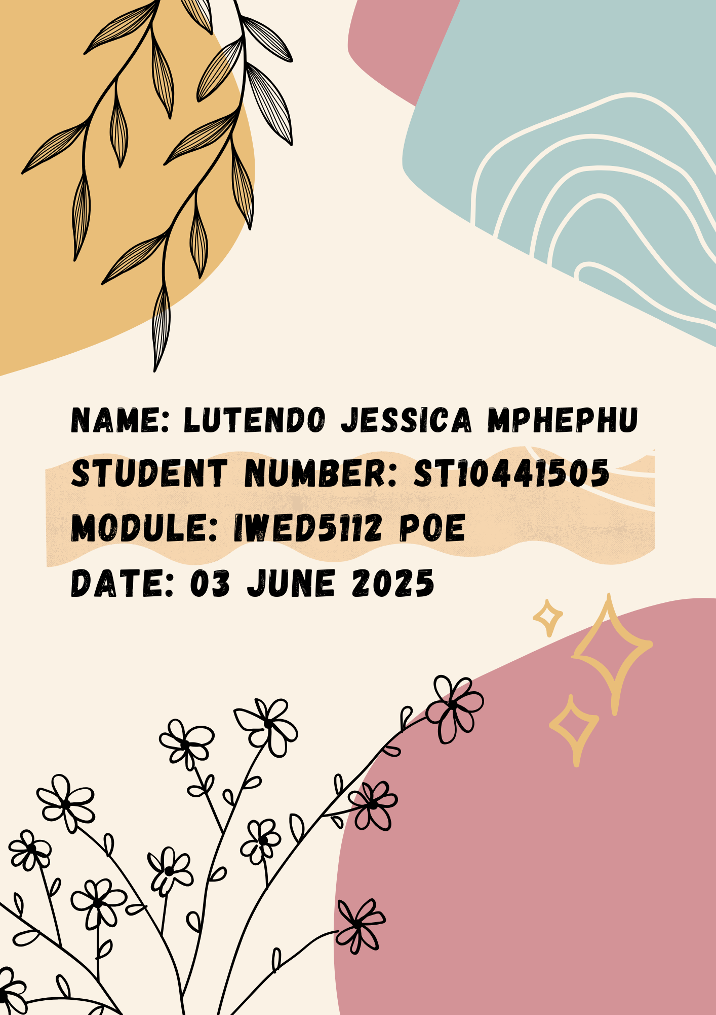

***Table of Contents***

* *Cover Page*
* *List of figures (From Part 1-3)*
* *Motivation (From Part 1)*
* *Objectives (From Part 1)*
* *List of Resources (From Part 1)*
* *User Persona (From Part 1)*
* *Site Map (From Part 1)*
* *Refinements and Improvements from Part 1 Feedback and Reflection (Part 2)*
* *Refinements and Improvements from Part 2 Feedback and Reflection*
* *Implementation of JavaScript*
* *Implementation of Responsiveness for Mobile*
* *Implementation of SEO*
* *Going Live Steps*

***List of Figures***

***Tru-Cape Logo***

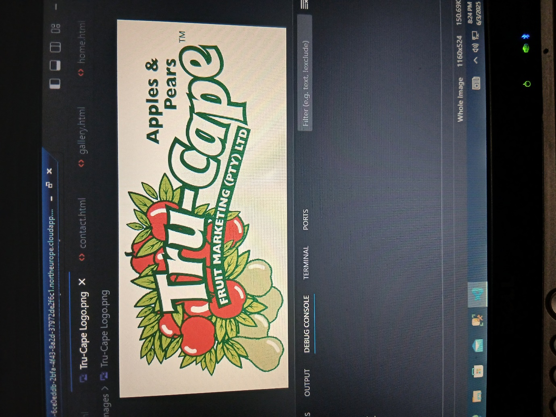

***Google Maps (Location)***

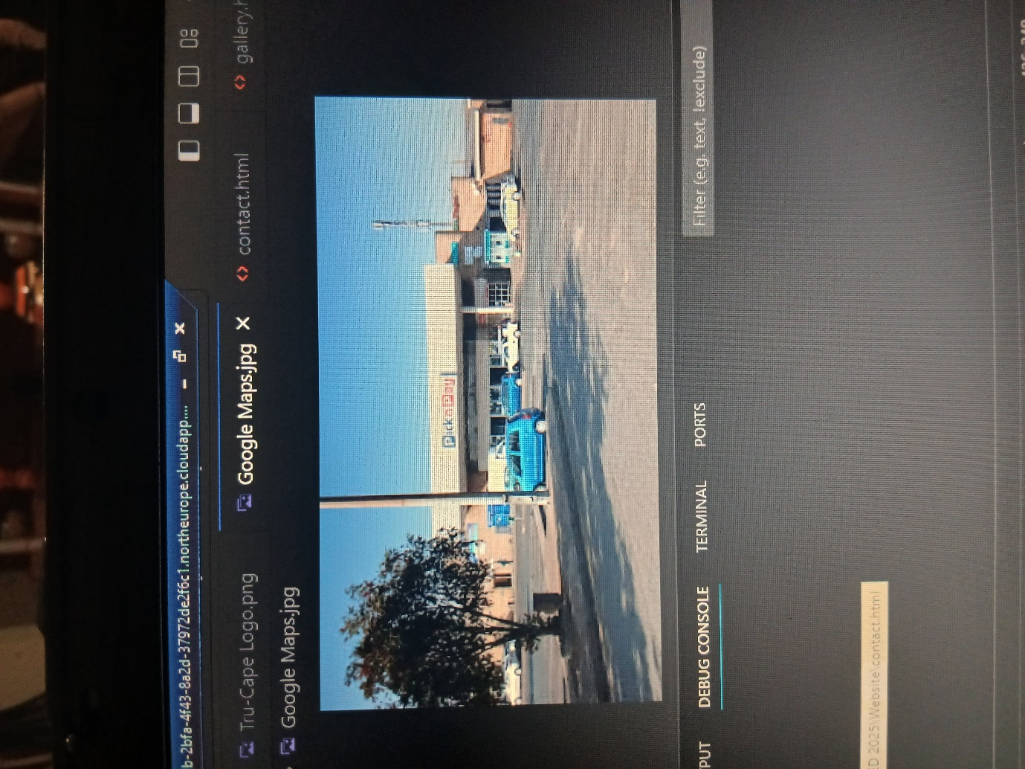

***Green Apples (Product)***

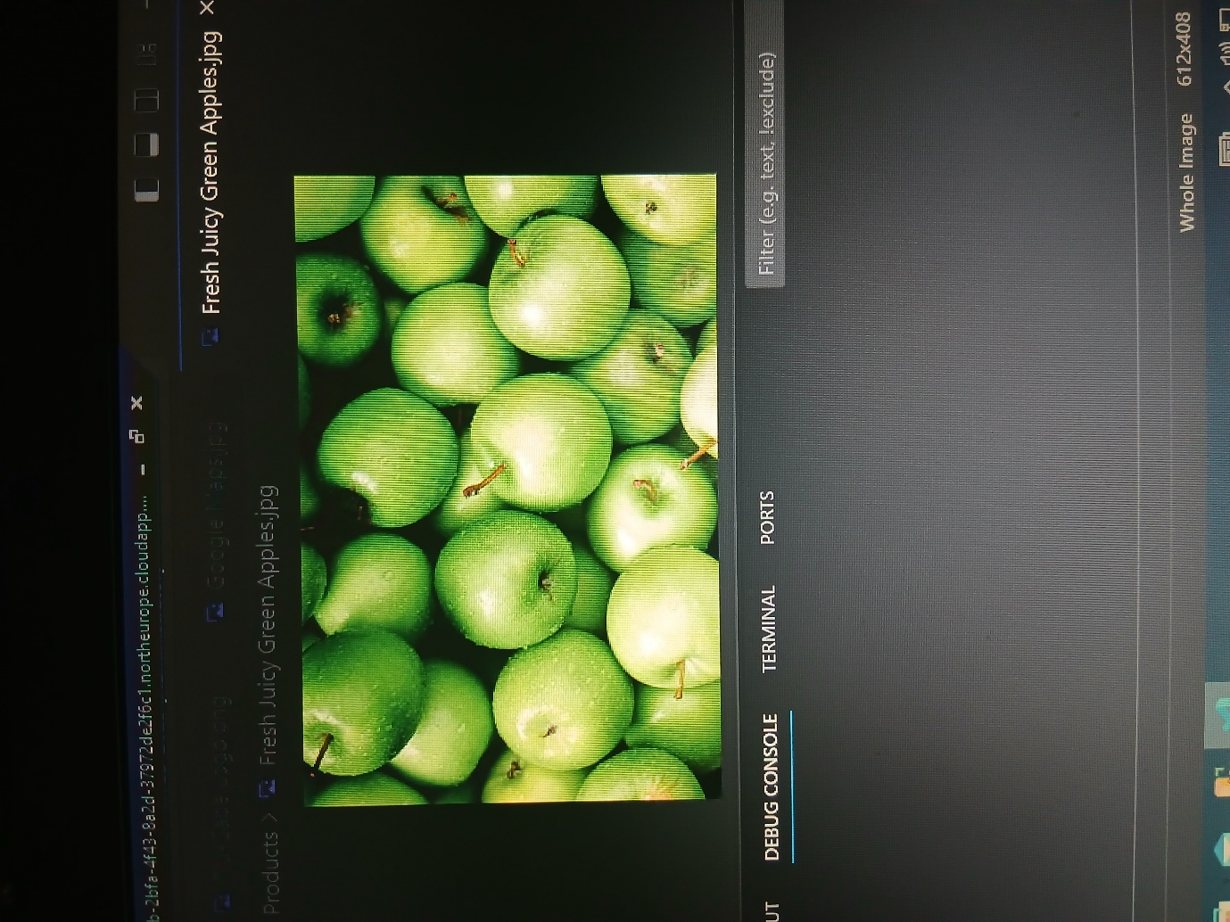

***Red Apples (Product)***

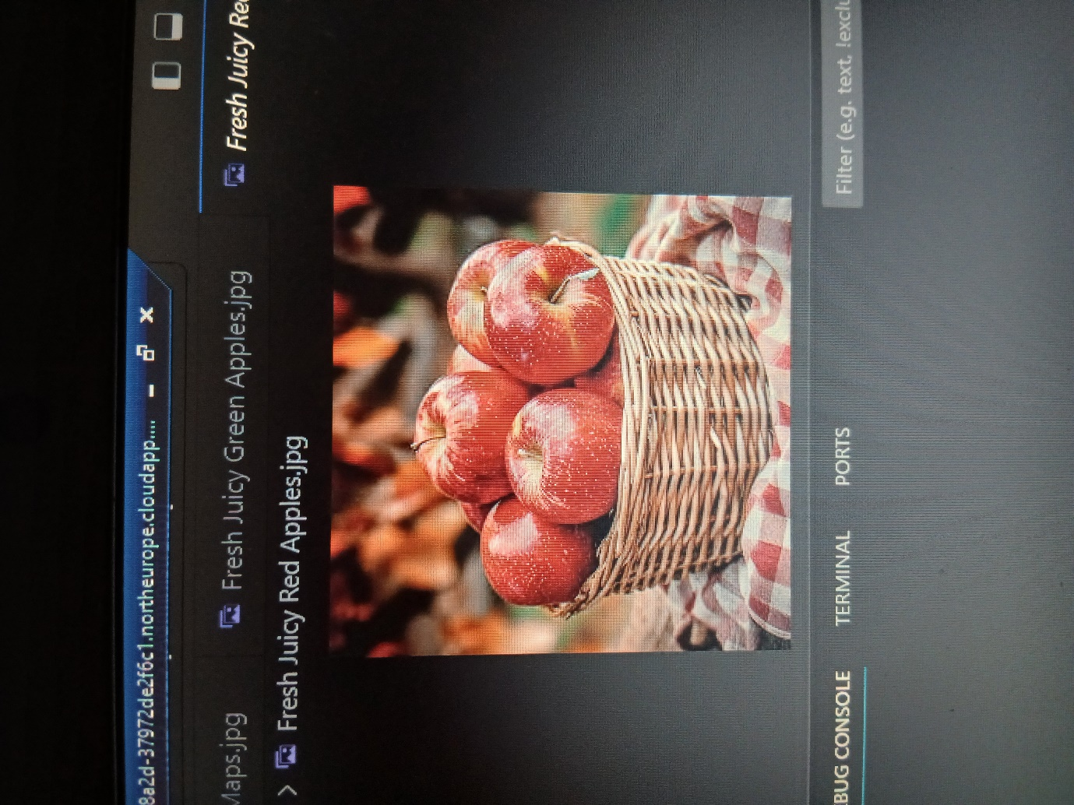

***Green Pears (Product)***

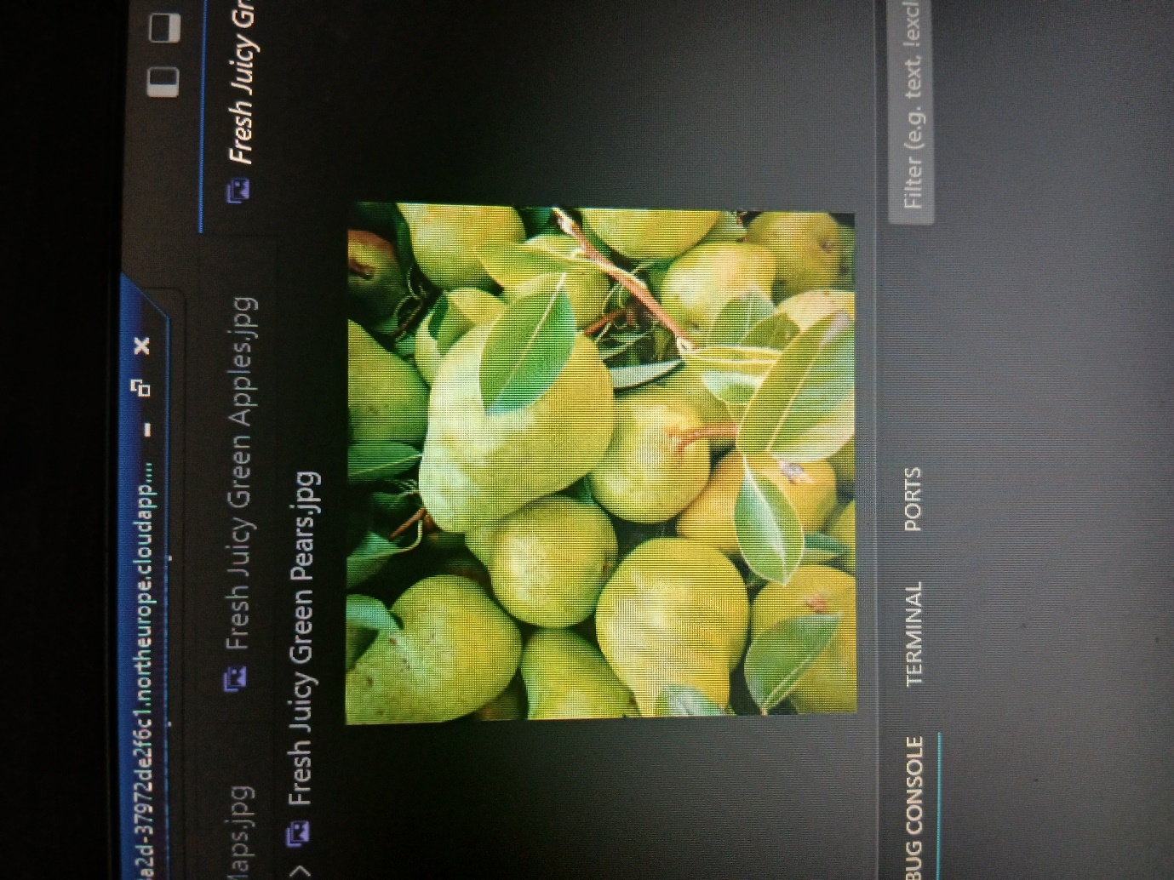

***Motivation for developing a Website***

***Increasing Online Presence***

* *Having a dedicated website enhances Tru-Cape’s visibility. It will serve as a digital footprint, making it easier for potential customers to find the brand (Yalanska, 2025).*

***Reaching a Broader Audience***

* *A website enables Tru-Cape to reach a global audience, transcending geographical limitations. An online platform provides access to a wider market (Yalanska, 2025).*

***Objectives***

***Brand Awareness***

* *It allows Tru-Cape to build a strong brand recognition and positive associations (Yalanska, 2025).*

***Customer Acquisition***

* *The website plays a crucial role in attracting new customers and driving sales (Yalanska, 2025).*

***User Persona Profile: Clive D. Smith***

***Basic Information***

* *Name: Clive D. Smith*
* *Role; Founder and Managing Director of Tru-Cape Fruit Marketing*
* *Location: South Africa*

***Demographics***

* *Age: Approximately 50-60 years old.*
* *Education: Degree in Agriculture, Business Management*
* *Experience: Over 20 years, with significant experience in fruit production, marketing, and management.*

***Professional Background***

* *Founding Tru-Cape: Launched the company in 1991 emphasizing sustainable practices and high-quality fruit export.*
* *Industry Contributions: Actively involved in promoting best practices in agriculture, advocates for sustainability and innovation.*

***Goals and Motivations***

* *Primary Goal: To position Tru-Cape as a leading exporter of high quality apples and pears globally.*
* *Motivations: Passion for agriculture. Commitment to environmental sustainability, support for local farmers and communities.*

***Implementation of SEO***

* *SEO (Search Engine Optimization) is the practice of improving a website’s visibility and ranking on search engine results pages (SERPs) (Shepherd, 2022).*
* *I was very specific with the SEO keywords I used such as “Green Apples, Red Apples and Green Pears” so the consumer can easily find the products that they are looking for.*

***Going Live Steps***

***Steps on How to go Live on GitHub***

***1. Create a New GitHub Repository***

1. ***Sign in to GitHub****: Go to* [*GitHub*](https://github.com/) *and sign in to your account (or create one if you don’t have it yet).*
2. ***Create a New Repository****:*

* *On the top right of your GitHub homepage, click the* ***+*** *button and select* ***New repository****.*
* *Name your repository (e.g., my-website).*
* *Make it* ***public*** *(this is important for GitHub Pages to work).*
* *Initialize with a README.md (optional).*
* *Click* ***Create repository****.*

***2. Add Your Website Files***

*Now, you need to add the files of your website (e.g., index.html, style.css, script.js).*

***Option 1: Upload Files Directly (Web Interface)***

1. *Open the repository you just created.*
2. *Click on* ***Add file*** *>* ***Upload files****.*
3. *Drag and drop your HTML, CSS, and other files here.*
4. *Commit the changes (click* ***Commit changes****).*

***3. Enable GitHub Pages***

1. ***Go to Repository Settings****:*

* *In your repository, click on* ***Settings*** *(found in the tab bar under the repo name).*

1. ***Configure GitHub Pages****:*

* *Scroll down to the* ***Pages*** *section on the left sidebar (or under* ***Code and automation****).*
* *Under* ***Source****, select the branch you want to deploy from (typically main or master).*
* *Choose the* ***root*** *directory for the source (this is where index.html should be located).*
* *Click* ***Save****.*

***4. Access Your Live Site***

* *After saving, you will see a message like this:*
* *It may take a minute for the site to go live. Once it’s ready, visit the link, and you should see your website live on GitHub Pages!*

***5. Customize Your Domain (Optional)***

*If you want to use your own domain (e.g., www.yoursite.com):*

1. ***Buy a Domain****: Purchase a domain from any domain provider (e.g., GoDaddy, Namecheap).*
2. ***Configure DNS****:*

* *Go to your domain provider’s DNS settings and add the following records:*
* ***CNAME****: www -> yourusername.github.io*
* ***A records****: Add GitHub’s IP addresses (found in GitHub documentation).*

1. ***Add Custom Domain to GitHub****:*

* *Go back to the* ***Pages*** *section in your repository settings.*
* *Under* ***Custom domain****, enter your domain name (e.g., www.yoursite.com).*